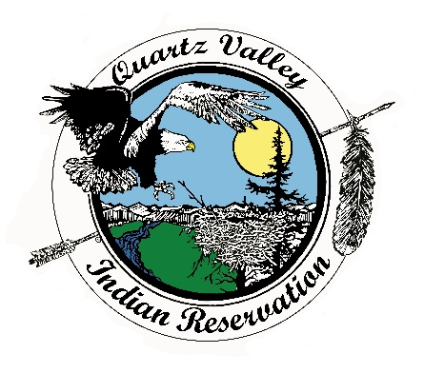
Quartz Valley Indian Reservation

Position Description

Job Title: | Accounts Receivable Specialist
Department: | Anav Tribal Health Clinic - Administration
Primary Location: | Anav Tribal Health Clinic
Classification: | Full-Time, Non-Exempt
Reports to: | Business Office Manager
Salary: | Depending on Experience

Primary Purpose
The Accounts Receivable Specialist is responsible for processing and posting all payments and EOB denials. To assure timely reimbursement to the Clinic and manage the accounts receivable, the Specialist will review and research past due accounts, follow-up on unpaid claims, and make collection calls on unpaid accounts. The primary purpose of this position is to assume responsibility of the accounts receivable. They will be responsible to know and understand the details of what accounts receivable consists of and prepare monthly reports including but not limited to aging and cash flow reports. Communication with patients and assisting with front office duties may be required occasionally.

Essential Functions

- Responsible for all third party and patient statement billing using RPMS (Resource and Patient Management System) A/R software.
- Process all EOB payments and denials. In cooperation with clinic Biller, follow up on unpaid claims and patient accounts and perform necessary research and functions towards collection.
- Assume responsibility of the accounts receivable.
- Understand the details of what accounts receivable consists of (Medicare, private insurance, self-pay, etc.).
- Prepare monthly accounts receivable reports and be able to explain increases, decreases, and trends.
- Prepares summary of proposed write offs and adjustments.
- Collect and reconcile cash boxes and prepare deposit slips.
- Post cash payments into the RPMS.
- Maintain a filing system for all A/R related documents to ensure efficient retrieval.
- Maintain a desk manual.
- Assist in front office duties as needed.
- Maintain positive working relationship with all staff in all departments.
- Other duties as assigned.
Competencies

To perform this job successfully an individual must be able to perform each essential duty satisfactorily. The requirements listed below are representative of the knowledge, skill and/or ability required. Reasonable accommodations may be made to enable individuals with disabilities to perform the essential functions.

Education
- Graduation from high school or the equivalent required. Accounting or Bookkeeping education preferred.

Proficiencies
- Knowledge of standard office policies and procedures. Skill in organizing time and managing multiple demands as well as dealing with patients and visitors or other staff members.
- Knowledge of traditional health insurance plans, Medicare, and Workers’ Compensation.
- Knowledge of CPT and ICD coding principles. Understand EOB’s and have the ability to decipher them. Understanding of concept of maximum reimbursement.
- Accuracy with data entry and 10-key skills. Knowledge of accounts receivable management, aging reports, and completion of reconciliations.
- Ability to research and take necessary action to collect on unpaid claims and patient accounts.
- Skillful in the use of calculators, computers, spreadsheet software, and patient management software.
- Ability to work independently and use good judgment in work prioritization Ability to complete difficult/complex tasks. Ability to follow oral and written instructions.

Experience
- Two years of appropriate office work experience, including at least six months working with and managing accounts receivable. Experience with RPMS and with doing reconciliation’s preferred. Must have working knowledge of insurance/billing/payment procedures as well as ICD/CPT coding principles. Substitution: Satisfactory completion of an appropriate vocational training course of study such as medical office training may be substituted for up to one year of the required two years of office work experience.

Other Requirements

- Must be able to pass background check.
- Must adhere to Tribal drug and alcohol policy, including pre-employment drug and alcohol screening.
- Must have a valid driver’s license and insurable under the Tribe’s insurance policy.

Receipt and Acknowledgment

- The contents of this job description are job requirements, and, at this time, I know of no limitations that would prevent me from performing these functions with or without accommodation. I further understand that it is my responsibility to inform my supervisor at any time that I am unable to perform these functions.
- Job duties, tasks, work hours and work requirements are subject to change.
- Acceptable job performance includes execution of essential functions while maintaining professional conduct and compliance with all QVIR polices, including, but not limited to: QVIR Personnel, Travel, Fiscal, and Purchasing Policy.

Indian Preference:
In accordance with CFR 25, Part 276 and in accordance with Title VII of the Civil Rights Act, Section 701(b) and 703(i), preference in filling all vacancies will be given to qualified American Indian candidates.

Veteran Preference:
In accordance with QVIR Personnel Policy, applicants with documented Veteran status (such as DD-214) will be given preference in filling vacancies.

For questions regarding this position description, including applications, please contact Quartz Valley Indian Reservation Human Resources at 530-468-5907 or humanresources@qvir-nsn.gov

Employee signature below constitutes employee's understanding of the essential functions, competencies, and requirements of the position.

Print Name |  | Signature |  | Date

Approved

Business Council  or  Health Board |  | Signature |  | Date

