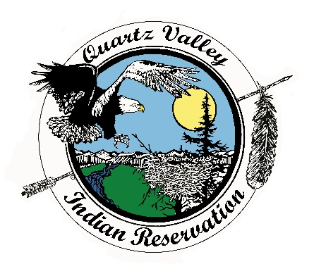
Quartz Valley Indian Reservation

Position Description

Job Title: | Community Health Representative (CHR)
Department: | Medical
Primary Location: | Anav Tribal Health Clinic
Classification: | Full-time, Regular, Non-Exempt, Non-entry level
Reports to: | Medical Director
Salary: | DOE

Primary Purpose
Shall be a community-based health care provider who furnishes paraprofessional community oriented primary care, disease prevention services and traditional Native concepts in multiple settings within the Quartz Valley area under the direction of the Medical Director or designee.

Essential Functions

- Shall capably facilitate communication between community members and health care providers acting as a client advocate and improving access to health care.

- Shall skillfully prepare and maintain a visitation schedule with all eligible residents in their area. Visitation should include, but not be limited to, evaluation of the health status, public health needs and well-being of Tribal Members of all ages.

- Under the medical supervision of the medical provider or designee, performs health assessments and screenings, including, but not limited to: testing blood sugar levels, checking vital signs, vision screening, performing blood hemoglobin assessments, podiatry checks, etc.

- Shall capably provide specific areas of health education including diabetes, hypertension, maternal and child health, immunizations, health promotion and disease prevention. Health Education shall be provided one on one, in family, and/or group settings.

- Collects data, maintains patient and family records, and writes reports. Coordinates activities and shares appropriate data with the medical provider and/or medical staff designee.

- Exhibits the ability to work and communicate in a team-oriented way with other outreach staff, other Tribal departments and supervisor in order to meet client/patient needs.

- Enters data and information related to field visits and health screenings into the EHR/RPMS software in order to adequately provide monthly reports to supervisor summarizing activities.

- Shall readily be available for local and out of the area travel as required for job related training. Shall attend all required meetings and functions as requested.
- Provides assistance with community health clinics (i.e., pediatric clinics, diabetes screenings and specialty clinics).

- Provides emotional support and advice through follow up with clients newly diagnosed with a chronic or serious illness or injury and their families, clients in domestic violence settings, clients experiencing loss, and other situations which affect family health and well-being

- Is courteous in accepting other job duties as assigned.

Competencies

- Must possess high school diploma or equivalent.

- Experienced in healthcare related field such as: Emergency Medical Technician (EMT), First Responder, Phlebotomy, Dialysis Technician, Certified Nurse Assistant, Medical Assistant, and/or IHHS Caregiver. Experience may be substituted with academic training such as Certified Nurse Assistant or Certified Medical Assistant, or certification (12 semester units) in early childhood development.

- Must complete CPR & First Aid training within the first 90 days of employment and keep current certification.

- Must complete the Basic and Advanced IHS web-based training modules within the first 6 months of employment.

- Must possess valid driver’s license, good driving record and be insurable by the Tribe’s insurance carrier.

- Must strictly adhere to the confidentiality and HIPAA policies.

- Must successfully pass a pre-employment drug screening test and be willing to submit to a criminal background check.

- Must provide documentation of hepatitis B or refusal, MMR or refusal. Also be willing to have annual TB testing.

Other Requirements

- Must be able to pass background check.
- Must adhere to Tribal drug and alcohol policy, including pre-employment drug and alcohol screening.
- Must have a valid driver’s license and insurable under the Tribe’s insurance policy.

Receipt and Acknowledgment

- The contents of this job description are job requirements, and, at this time, I know of no limitations that would prevent me from performing these functions with or without accommodation. I further understand that it is my responsibility to inform my supervisor at any time that I am unable to perform these functions.
- Job duties, tasks, work hours and work requirements are subject to change.
- Acceptable job performance includes execution of essential functions while maintaining professional conduct and compliance with all QVIR polices, including, but not limited to: QVIR Personnel, Travel, Fiscal, and Purchasing Policy.

Indian Preference:
In accordance with CFR 25, Part 276 and in accordance with Title VII of the Civil Rights Act, Section 701(b) and 703(i), preference in filling all vacancies will be given to qualified American Indian candidates.

Veteran Preference:
In accordance with QVIR Personnel Policy, applicants with documented Veteran status (such as DD-214) will be given preference in filling vacancies.

For questions regarding this position description, including applications, please contact Quartz Valley Indian Reservation Human Resources at 530-468-5907 or humanresources@qvir-nsn.gov

Employee signature below constitutes employee's understanding of the essential functions, competencies, and requirements of the position.

Print Name |  | Signature |  | Date

Approved

Business Council  or  Health Board |  | Signature |  | Date

